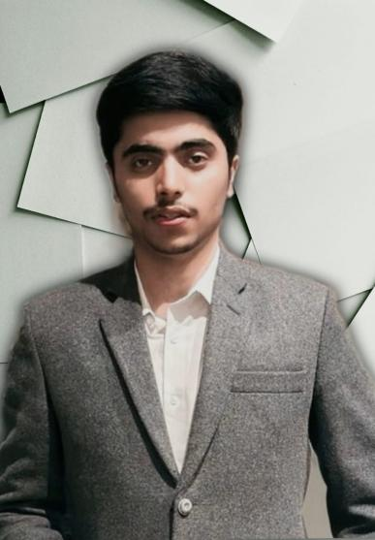 |  | Muhammad Daniyal Waseem | 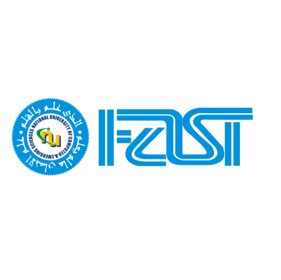
 |  | "Resume to grab Internship for specifically web development and generally software development"
EDUCATION  BS Software Engineering  FAST-NUCES, Lahore  08/2022 - 08/2026  SKILLS  - HTML,CSS,TailwindCss  - Bootstrap,Mui-Materials,ThymeLeaf  - Full MERN Stack (Backend+Fontend)  - Java,JavaSpringBoot,  - JavaScript,TypeScript  - C++ .netframework desktop application development  - SqlServer, MongoDb ,MySql Database  - PF, OOP, Data Structures, Database  CERTIFICATES  - SOFTEC’23,  - NeSCon’23  - ACM’23 |  | Personal Details  University: FAST-NUCES, Lahore  Semester: 4th undergraduate (Expected Graduation: 2026)  Address: 275 Block E Sabzazar Multan Road, Lahore  Contact: (+92)3320429421,+923284180056  E-mail: daniyalwaseem0808@gmail.com  Linked-In Profile:www.linkedin.com/in/daniyal-waseem-039352249  Projects  - Islamic App (Desktop Version) at university level in C++ .netframework windows form and using SQL database.  - Islam786 (website) using React + tailwindcss+Api with full responsiveness .  - A website front-end basically a clone of the website (BBC.com,Facebook,Amazon, spotify.com) home page fully responsive.  - Ecafe ( A cafe management system website) implemented using MySQL, Java Spring Boot, Thymeleaf, and Bootstrap  - BakeNest (E-commerce website) implemented using MySQL, React.js, Node.js, Express.js, Tailwind CSS, and React MUI materials.  Note: I can showcase all these projects during the interview. The website is currently stored locally and not hosted. Additionally, you can view my project videos that I have uploaded on LinkedIn.

